**Deliverable 3: Sprint #1**

**Team 14: /root**

Vincent Ho

Nanson Yuan Zan Zheng

Dimitar Stratiev

Kirishanth Ganeshamoorthy

Xibo Rao (Robbie)

***Table of Contents:***

1. **Project Planning**
   1. Updated Product Backlog………………………………………………………………………………………………. 1
   2. Updated Sprint Backlog and Spring Plan..………………………………………………………………………. 2
      1. Sprint Plan …..………………...……………………………………..…………………………………………. 2
      2. Sprint Backlog………………...……………………………………..…………………………………………. 2
   3. Updated System Design...…………...……………………………………..…………………………………………. 2
   4. Updated Burndown Chart…………...……………………………………..…………………………………………. 2
   5. Task Board Snapshot…………………...……………………………………..…………………………………………. 3
      1. Beginning of the Week…...……………………………………..…………………………………………. 3
      2. Middle of the Week..……...……………………………………..…………………………………………. 3
      3. End of the Week..…………...……………………………………..…………………………………………. 4
2. **State of Project**
   1. Reasons for Changes.……..………………………………………………………………………………………………. 4
   2. Reasons for Lack of Progress…...…………………………………………………………………………………..4, 5

***Project Planning***

***Product Backlog:***

1. As Natalie, a Historian, I want a button to create a new description field on custom forms so I can customize the descriptions for specific files

* Value: 10
* Cost: 55

2. As Natalie, a Historian, I want a button to delete existing description fields on forms so I can remove descriptions that are no longer relevant for my files

* Value: 10
* Cost: 10

3. As Natalie, a Historian, I want to save custom forms with new or modified description fields so I can have the same description fields for similar files

* Value: 10
* Cost: 40

4. As Natalie, a Historian, I want a button to modify existing description fields on forms so I can have more specific descriptions for my files

* Value: 9
* Cost: 10

5. As Natalie, a Historian, I want a checklist prompt to save changes across all identical files in all directories so my files are consistent

* Value: 8
* Cost: 35

6. As Natalie a Historian, I want to be able to rename all identical tags at once across all files and directories.

* Value: 7
* Cost: 10

7. As Natalie, a Historian Professor, I want to batch remove tags, so I can remove tags without having to manually delete them

* Value:6
* Cost: 10

8. As Natalie, an organized Historian, I want a button which combines existing tags together so I can have more general tags without having to create a new tag

* Value: 5
* Cost: 20

9. As Natalie, a Historian, I want a GUI for modifying or creating citation styles so I can use specific citations that suit the documents I am saving

* Value: 3
* Cost: 55

***Updated Spring Backlog and Sprint Plan:***

Sprint Plan

**1 Story Point = 1 Developer Hour**

**Spike #1:** Learn JavaScript – SP: 17

**Task #1:** create XUL files for installation of our Zotero extension – SP: 2

**Task #2:** documentation of functions – SP: 3

**Task #3:** Implement a function to search for all relevant items, given a list of tags – SP: 5

**Task #4:** Implement a function to delete a tag from all items containing the tag – SP: 1

**Task #5:** Implement a function to add a new tag to multiple items – SP: 1

**Task #6:** Implement a button on Zotero’s default window for batch editing tags – SP: 10

**Task #7:** Incorporation of JavaScript functions and GUI

Sprint Backlog

Please refer to “Sprint #2 – Sprint Backlog.xlsx” for updated Spring Backlog

***Updated System Design:***

Please refer to “System Design Revised.png” for updated System Design

***Updated Burndown Chart:***

Please refer to “Sprint #2 Burndown Chart.xlsx” for details

***Task Board Snapshot***

Beginning of the Week:

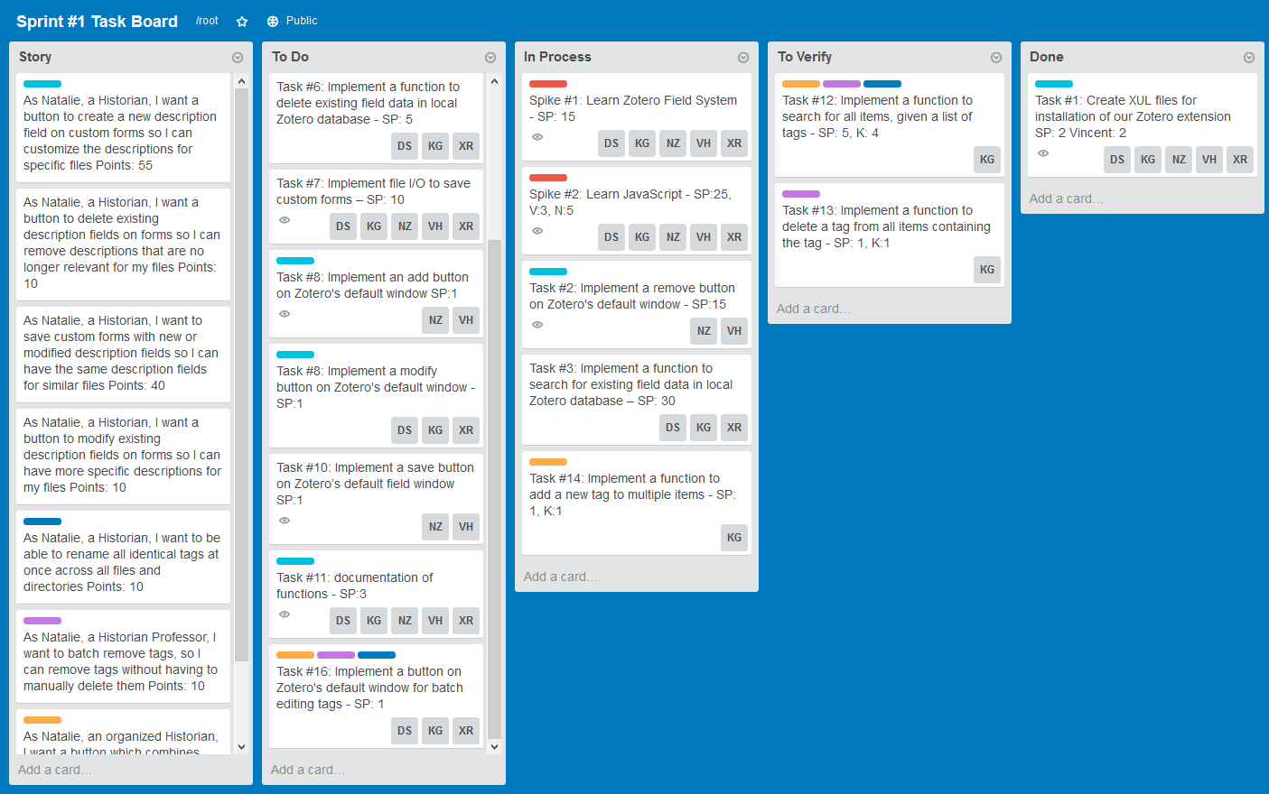

Middle of the Week:

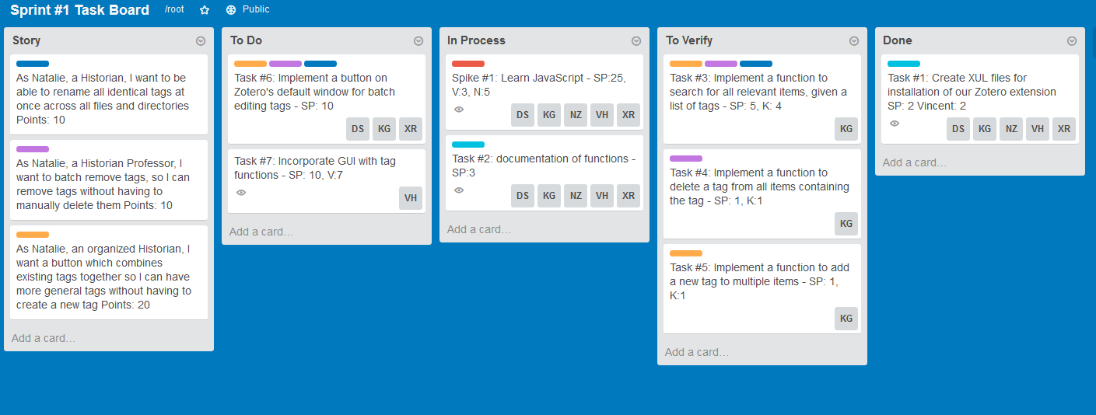

End of the Week:

**State of Project**

***Reasons for Changes:***

Our priorities shifted from working on Natalie’s number one priority of custom field forms to batch tag editing. We made more progress on tag editing than the custom fields, so we decided to prioritize building a fully functioning plugin before attempting to do another feature.

***Reason for lack of progress:***

**Note:** The plugin as of December 1st does not have any working functionality, most of the functions have been completed and all that’s left is linking the JavaScript file and XUL file to interact properly with Zotero and to fix and add some functions.